IEEE PES Talk on May 21st, 2015 at CalPoly Pomona on the topic “An Overview of GIS Substation Engineering”
IEEE Foothill Society PES chapter and IEEE PES student chapter, Cal Poly Pomona are pleased to sponsor a talk on the topic, an overview of GIS substation Engineering, by Mr. Tom Antonucci for the benefit of IEEE, particularly the student members, with an interest to Power Systems. This talk will be the next in a series of talks on Power Systems engineering the IEEE Foothill Society PES chapter is planning for the student chapter members.
GIS Substations:
GIS substations offer unique advantages over air-insulated applications. GIS substations use SF6 gas that reduces the distance needed between active and non-active switchgear parts resulting in smaller overall space requirements (ideal for congested city areas). GIS substations also offer lower operating and maintenance costs; and are less sensitive to pollution, salt, sand and large amounts of snow.
The talk is schedule for the 21st May, 2015, at Cal Poly, Pomona. This is a Thursday evening. The schedule of the talk is as follows:
Address: California State Polytechnic University, Pomona
3801 West Temple Avenue, Pomona, CA 91768
Building: 9 Room: 283
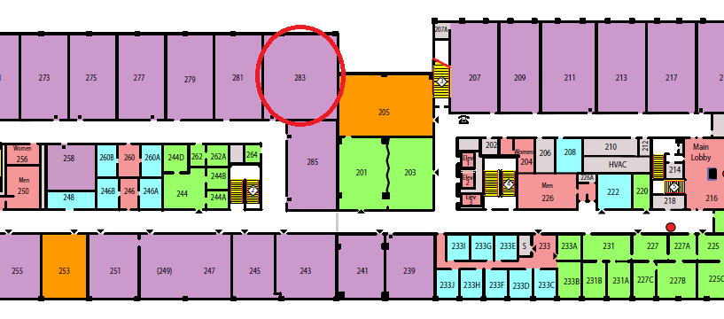
Parking: Parking Structure (which has self-service parking dispensers). Please note: $3.00 fee to park on CPP campus on Saturday for this talk. Please carpool as convenient to you and your associates.
GPS location for parking: 34.060253,-117.816782

Event Schedule:
7 PM – 7:30 PM: Networking and Dinner
7:30PM-08:30PM: Talk by Mr. Tom Antonucci
GIS - Gas Insulated Substation (or Switchgear) is a tool for utilities, primarily to address space constraints. This talk will address:
- Overview of GIS, including some of the science involved
- GIS drivers and tradeoffs in substation design and maintenance
- Observations based upon experience with GIS equipment in the field.
8:30PM – 9:00PM: Q&A Session
Speaketr’s Bio:
Tom Antonucci is the Engineering Compliance and Quality Manager for the Transmission and Distribution Business Unit at Southern California Edison. His previous roles at SCE have included Emerging Technologies Program Manager, Staff Engineering Manager, and Engineering Manager – Special Projects.
Prior to joining SCE, Tom worked for Rain Bird Inc. as General Manager and Engineering Manager, Texas Instruments as Senior Design Engineer, and TRW Automotive as Project Engineering Manager and Senior Design Engineer. Tom has extensive experience in new product development, holding patents in automotive crash sensing, low-volume irrigation, and wireless communication.
Tom attended the Massachusetts Institute of Technology, earning a Bachelor of Science degree in Mechanical Engineering, minor in Economics. He also received a Master’s in Business Administration from the University of Southern California.

