Inland Empire

IEEE Foothill Section

**TRIP REPORT**

**Report Originator(s)**

|  |  |
| --- | --- |
| Travel(s): | David E. González |
| Email(s): | [DavidGonzalez@ieee.org](mailto:DavidGonzalez@ieee.org) |
| To: | IEEE Foothill Section ExCom |
| Reporting: | Same as above |
| Date: | June 5th, 2018 |

**Business Trip Overview**

|  |  |
| --- | --- |
| Travel Destination: | Washington DC |
| Travel Period: | May 6th – 11th, 2018 |
| Event: | Science, Engineering, Technology Congressional Visit Day (SET CVD) |
| Purpose: | Visit nation’s Capitol and talk to Congressional Representative and Senators from California |
| Description | IEEE SET VCD is an annual event held at our Nation’s Capitol that allows the opportunity to Scientists, Engineers, and Technologist to share with U.S. Congressional Representatives and Senators what is of importance to IEEE and our local IEEE Foothill Section. |

**Summary**

My visit to Washington DC was quite interesting in that I saw for myself the hustle and bustle that occurs almost every day in our nation’s capitol. The day prior to our two-day visit to congress and the senate I attended a meeting at IEEE Washington DC headquarters and met some 60+ IEEE members from across the country that were there for IEEE SET CVD. We had a briefing meeting with the Russ Harrison and toured the IEEE Washington DC Headquarters. Mr. Harrison also gave each of us the agenda and scheduled events set for the next rtwo days, including the planned meeting with the congressperson from our respective districts. We also had some time to network and I was able to meet and coordinate with other IEEE members that formed from California contingent. The morning of our first day we had a briefing in one of the congressional auditorium from two Legislative Assistants from Republican and Democratic congressional representatives. The night of the first day of our SET VCD we were invited to an IEEE sponsored cocktail / networking hour. We socialized and shared business cards with other IEEE members, vendors, and some Legislative Assistants that attended. On the morning of day two I was scheduled to meet with the Chief of Staff from Congressman Mark Takano’s office, but both he and the congressman had to be in congress to hear testimony of Gina Haspel, then candidate and later confirmed CIA Director. I was attended by Congressman Takano’s Senior Legislative Assistant (Claire Viall) who sat with me and a representative from IEEE DC office along with IEEE member from the Orange County section. We asked her to please inform the congressman that IEEE wants him to push the Federal government to continue funding for basic research being done in our national laboratories and research & development (R&D) that is being done at universities and research facilities. I asked that for the Inland Empire that the Congressman help our local economy by supporting and increased investment in the areas of Logistics, Transportation Infrastructure (highways & railways), and Green Energy/Green Grids. In the area of education, I asked for increased funding to our universities and community colleges to invest in Cyber Security certificate/degree programs. I also visited Zoe Lofgren, who represents San Jose and part of Silicon Valley. We also mentioned to her the areas of importance for the IEEE USA and our local sections.

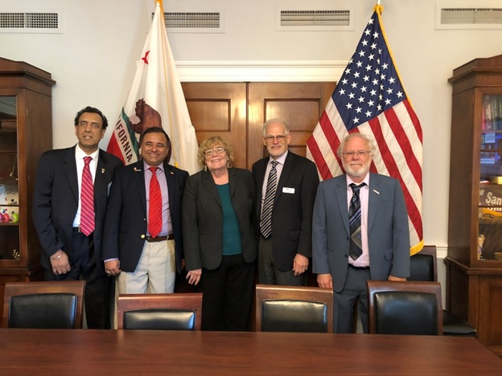

**California 2018 CVD Participants from California with Zoe Lofgren (CA-19th District Representative**

**[Left to right:  Upkar Dhaliwal (San Diego), David Gonzalez (Inland Empire), Zoe Lofgren (Congresswoman for CA 19th District),**

**Tom Coughlin (Santa Clara Valley) and Kenneth Kitlas (Oakland East Bay)]**

The California contingent also visited the offices of California senators Dianne Feinstein and Kamala Harris sharing with their Legislative Assistance our message. Aside from the busy two-days of meeting folks, we had time to take in the beauty of our nation’s capitol and the weather was wonderful during our time there.

**Conclusions / Recommendations**

Although some may not understand the purpose or value of visiting politicians that don’t have time to sit and talk to you, I do see it as an opportunity to establish initial lines of communications with our state and local representatives and give our Inland Empire Foothill Section visibility. This is a long-term investment of not only money but also of time. For me, it was great to network with IEEE members from other parts of the country. I gave me a different perspective on how they are solving similar problems we are facing as a section. Visiting the congressional and senate building and talking to legislative assistants gave me a better appreciation of what a great job our representatives and senators are doing for California.

I would recommend that next year we send another member of our section to IEEE SET VCD so she/he can not only appreciate the importance of IEEE government involvement but also continue our Region’s and section visibility in the political arena. As a section should discuss and document what are the concerns and issues of importance that the person we send should talk about to the congresspersons and senators. These concerns are not only as a section, but as residents of the Inland Empire amnd should help address long-term goals, like education, STEM, the health of our local economy, etc. I am giving myself the action item to follow up with Congressman Takano’s Riverside office and schedule a visit to that office. I plan on reaching out to Ken Calvert’s (CA-42nd district) and Pete Aguilar’s (CA-31ST district) local offices. I have already sent “thank you” emails to Congressman Takano’s Legislative Assistant and plan on sending similar emails to Senator Feinstein’s and Senator Harris’ office in DC.

More pictures: <https://drive.google.com/open?id=1ya6i70b1BA6GieeaB2vuBm7vtWHKuysS>

NOTE: You must be logged in to your IEEE email to see pictures